**Pipe Detection**

**K.Abhilash -22PC01**

**K.S.Saivenketraj -22PC28**

**Title**: Pipe Detection

**Abstract**: Training a model to detect number of pipes in a image.

**Problem** **Statement**: Using the dataset given, detect pipes of various shapes and sizes.

**Dataset and Preprocessing:**

* The dataset provided contained 103 images of pipes of various sizes.
* Initial model was trained using Hough transform and yielded a good result.
* For better accuracy and detection, we planned to use YOLO model.
* Since the dataset was not labelled, around 60 images were annotated using labelImg.
* Of the 60 images, around 45 was used for model training and rest for validation.

The dataset provided is in the [github](https://github.com/sai-venkii/Pipe-Detection/tree/master/data) link.

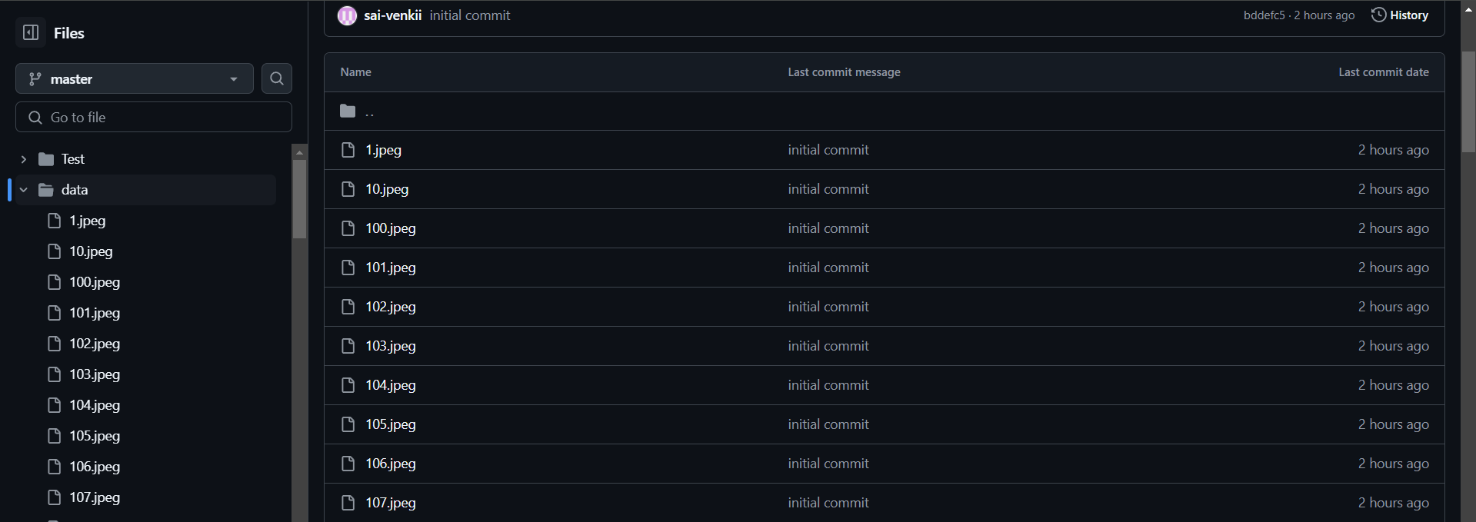

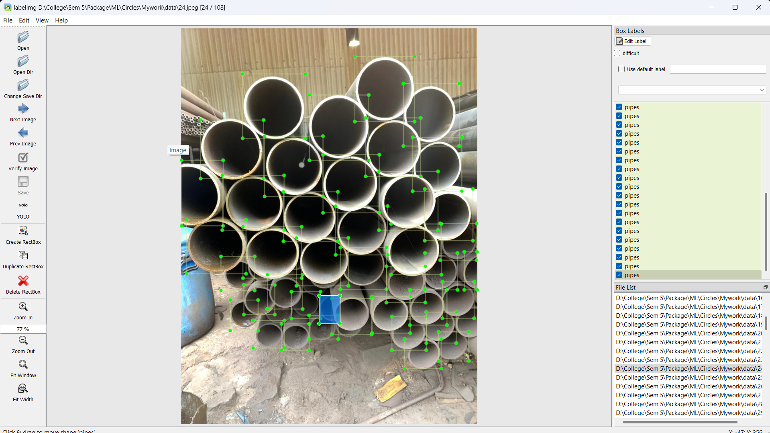

**Models Used:** YOLOv5, YOLOv10, YOLOv11n, YOLOv11s

**Implementation:** Trained 45 images in yolo to predict the number of pipes in a given sample.

**Model Evaluation and results:** Yolo works based on Iou, replay and accuracy measures.

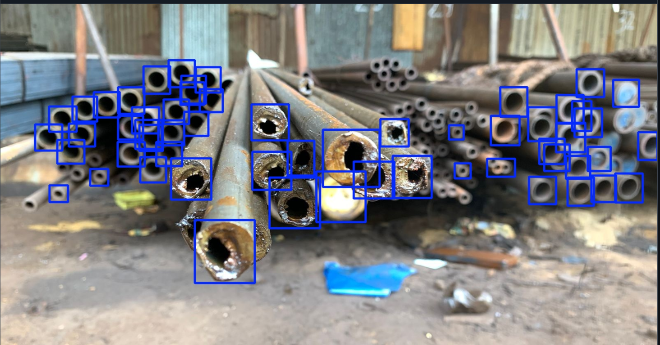

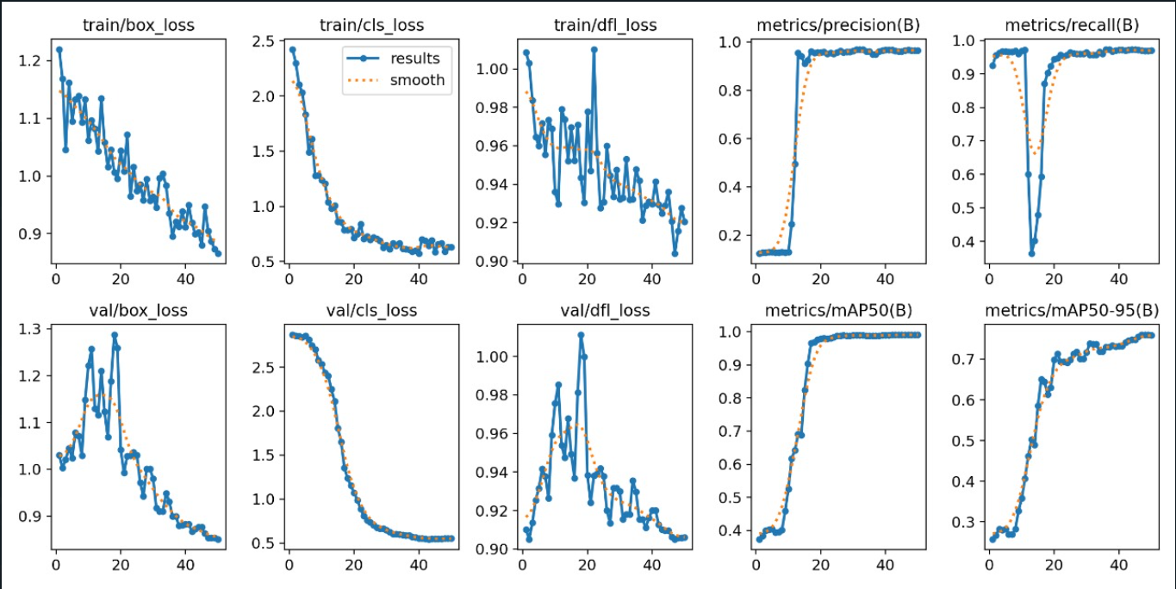

Yolo gives about 65 percent of accuracy with epoch of 60.

**GitHub Link:** <https://github.com/sai-venkii/Pipe-Detection>

**Video Link:** [**https://drive.google.com/file/d/1HnizgmYT3J6jFhPoeQKFVBlZpFo4Nu1T/view?usp=sharing**](https://drive.google.com/file/d/1HnizgmYT3J6jFhPoeQKFVBlZpFo4Nu1T/view?usp=sharing)

**Future Works:**

* Increase the model accuracy by gathering and annotating more pipe samples.
* Using R-CNN combined with Hough Transform

**Learning References:**

<https://blog.roboflow.com/yolov5-improvements-and-evaluation/>

<https://pytorch.org/hub/ultralytics_yolov5/>